MC900347477[1]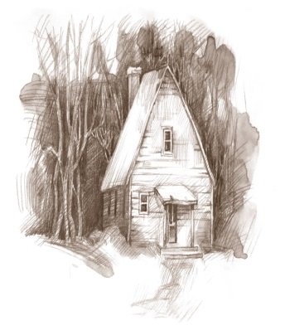**Cabin fever** is the term for a [claustrophobic](http://en.wikipedia.org/wiki/Claustrophobia) reaction that takes place when a person or group is isolated and/or shut in a small space, with nothing to do for an extended period. Cabin fever describes the extreme irritability and restlessness a person may feel in these situations.

A person may experience **cabin fever** in a situation such as being stuck at home in the winter. When experiencing cabin fever, a young athlete may tend to sleep more, be grumpy with their parents and siblings, and sit around playing video games, texting, or talking on their cell phone.

One therapy for **cabin fever** may be as simple as getting out and learning the sport of volleyball. Research has proven that practicing volleyball can promote improved cognitive functioning and overall well-being. Did we mention getting better at the sport too?

**Kaepa Borderline ‘Cabin Fever’ Training Program**

Getting ‘Cabin Fever’? So you never heard of it? Tired of lying around the house texting on your cell phone? Come and join the fun! Basketball will be over soon and softball and track haven’t started yet!

The ‘Cabin Fever’ training program is for athletes that didn’t make a club team or that didn’t try out for a team for a myriad of reasons. All sessions will be conducted at Phillips Hall on the Miami University Oxford campus. Members of the Borderline Junior Volleyball coaching staff, under the direction of ***Coach Clair Green***, will conduct the program. It begins on Saturday, February 1 and ends on Saturday, March 29. There are a total of 8 Saturdays of instruction and competition.

Each of the first 6 sessions will consist of 2 hours of instruction between the hours of 1-5 PM (The complete schedule will be determined when we have an idea of the number of participants.). The last two dates of the program will be 3-4 hours of games and competition each day. If there are enough members, we will run a small tournament for the members. Each session will cover several skills and their applications to the sport.

Athletes will be grouped according to age and grade. Group 1 is for boys or girls in grades 2-6. The second group is for girls in the 7th and 8th grade. The third group is for girls in high school. Training will be adapted to the skill level of the athletes attending.

MC900353709[1]The cost of registering for the full session is $250 if registered and paid by January 21 ($300 after this date). You may register for individual sessions as well. Registration is available at <http://borderlinevbc.org/signup.php>. In addition, each participant must also register with USA Volleyball using the Webpoint registration process, using the link at <https://www.ovr.org/docs/New-Junior-Girl-Member.pdf> for new members and <https://www.ovr.org/docs/Renewing-Junior-Girl-Member.pdf> for existing members. The fee of $10 applies for everyone that chooses ‘Kaepa Borderline Cabin Fever Training Program’ when registering. Contact Bill Zehler (Zehler@borderlinevbc.org) at 513-726-6739 if you have any questions.