SPIRITWEAR ORDER FORM

WE WILL BE OFFERING 3 DIFFERENT LOGOS FOR YOUR SPIRITWEAR. CIRCLE YOUR CHOICE OF LOGO. ALL ORDERS MUST BE PREPAID.

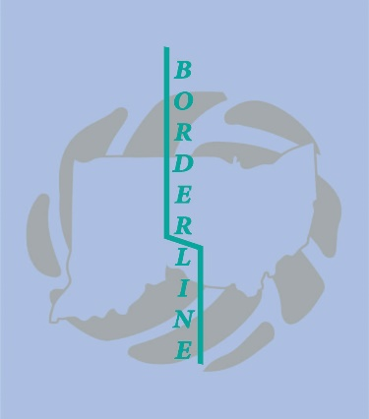 BACK LOGO

 BACK LOGO FRONT LEFT LOGO

Borderline Car Decal

RED T-SHIRT LONG SLEEVE $18________ SHORT SLEEVE $15 _______ SIZE__________

GRAY T-SHIRT LONG SLEEVE $18________ SHORT SLEEVE $15________ SIZE __________

HOODIE $30 GREY _______ RED_________SIZE________

XXL and XXXL ADDITIONAL $3.00

Name added is an additional $6.00_________________

Number added is an additional $4.00_______________

TOTAL ___________________

NAME___________________________________________

TEAM___________________________________________

PHONE_________________________

ADDITIONAL INSTRUCTIONS: