Quads Volleyball Tournament
4th,5th, 6th Grade
@ SPORTS EXPRESS
Saturday, December 9
4pm start (3:30 check in) - $60/team (donation)

To register - Email: CoachAmanda24@aol.com (Include grade & team name)

This is a charity event for:
Vivian's Battle vs Neuroblastoma
Daughter of Elevation coach: Erin Wilson

We will have raffle items, bake sale, and split the pot.
Please email: CoachAmanda24@aol.com with raffle donations!

Be strong and courageous, do not be afraid, for the Lord your God goes with you... Deuteronomy 31:6
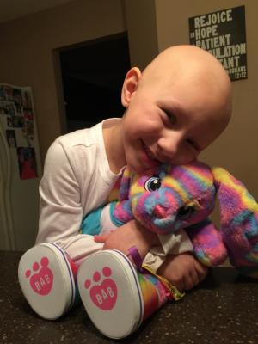
https://www.caringbridge.org/visit/vivianwilson77

