Borderline Spiritwear

Athlete Name:_____________________________________________
Team Name:_______________________________________________
Gray (Charcoal) Hoodie $35
___ YM __ YL __YXL __XS ___ S ___ M ___ L ___ XL ___ XXL ___XXXL

XXL add an additional $3
XXXL add an additional $5
Total:______ Paid:_____

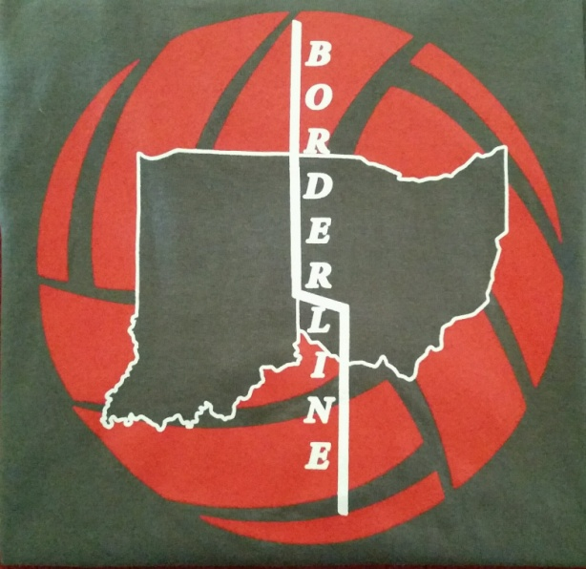
Center Back Logo

